**DevOps Engineer Assignment**

**Requirement 2- By: Ahmed Elbendary**

**Requirement 2- partA**

Github repo: <https://github.com/bendary7/eks-devops-project.git>

**Creating Amazon EKS cluster IAM role (steps in link):**

<https://docs.aws.amazon.com/eks/latest/userguide/service_IAM_role.html>

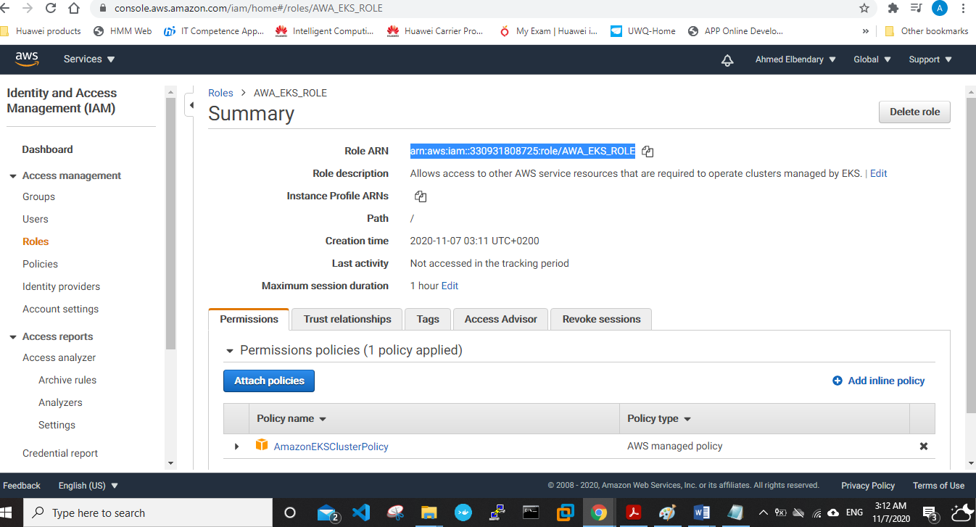

**Created an Ubuntu t2.micro instance to implement all my needed work on it:**

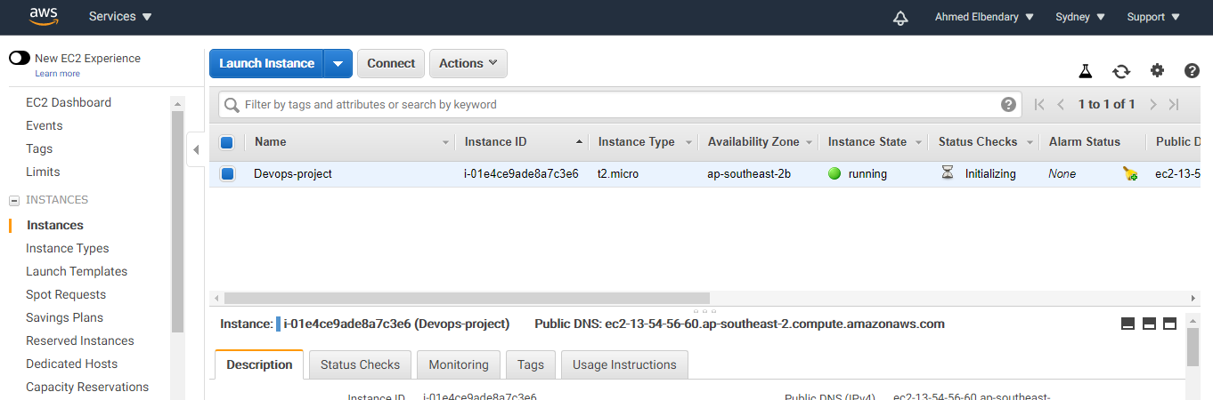

**Next, we need to install :**

* Awscli / Kubectl/ aws-iam-authenticator

# Installing kubectl steps in link:

# <https://docs.aws.amazon.com/eks/latest/userguide/install-kubectl.htm>

# 

# Installing aws-iam-authenticator steps in link:

# <https://docs.aws.amazon.com/eks/latest/userguide/install-aws-iam-authenticator.html>

# 

**creating vpc using cludformation template:**

[**https://amazon-eks.s3-us-west-2.amazonaws.com/cloudformation/2019-02-11/amazon-eks-vpc-sample.yaml**](https://amazon-eks.s3-us-west-2.amazonaws.com/cloudformation/2019-02-11/amazon-eks-vpc-sample.yaml)

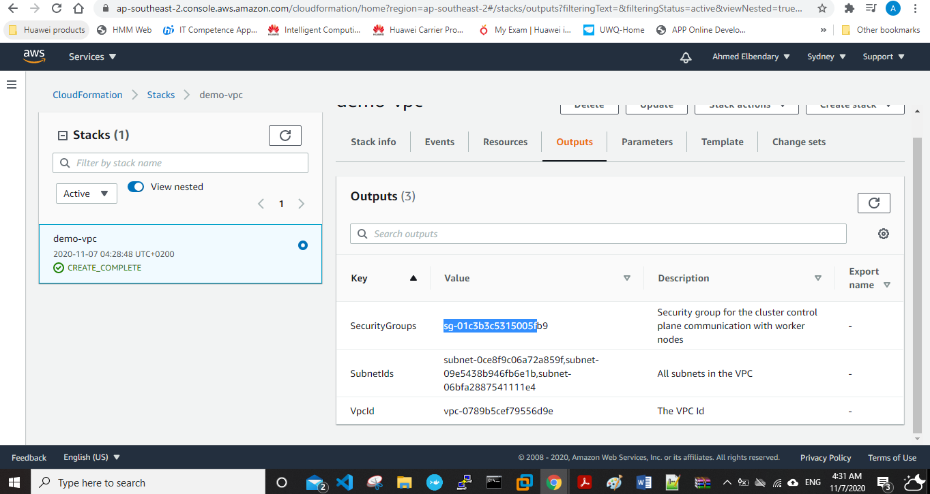

**Creating cluster:**

Refrence:- <https://docs.aws.amazon.com/cli/latest/reference/emr/create-cluster.html>

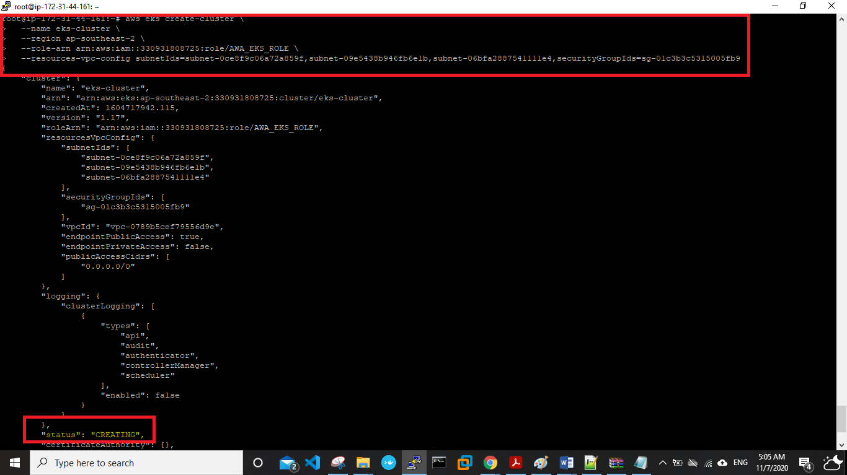

**Checking on cluster status:**



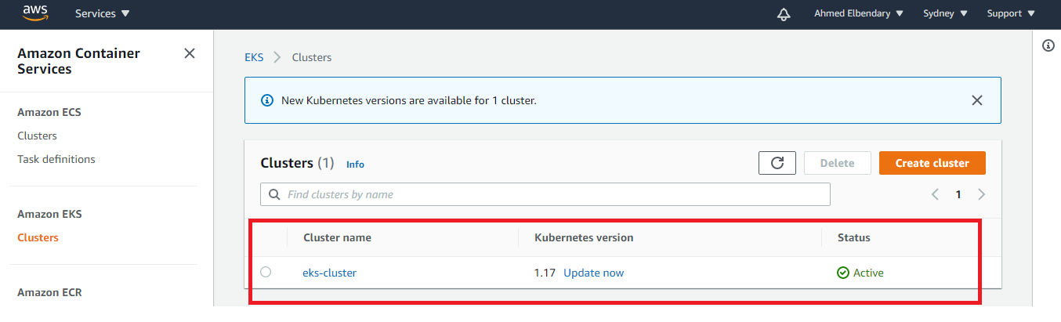

**Updating kubeconfig file with information on new cluster:**



**Checking on configuration:**

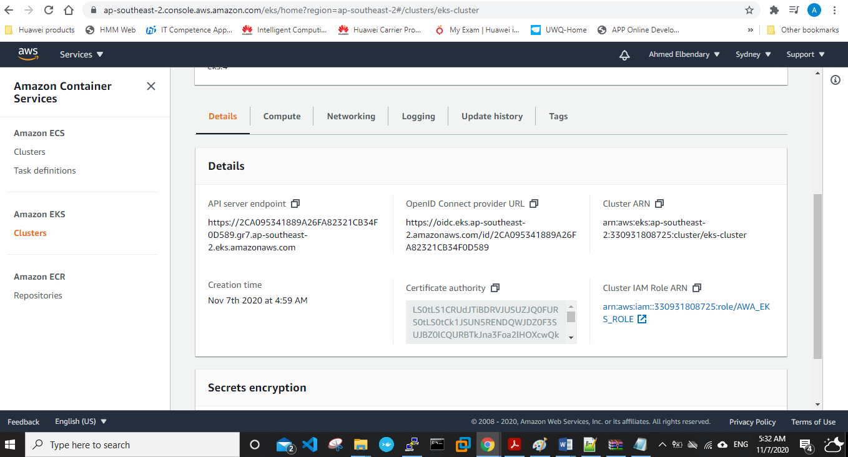

**EKS worker node created using “cloudformation” successfully:**

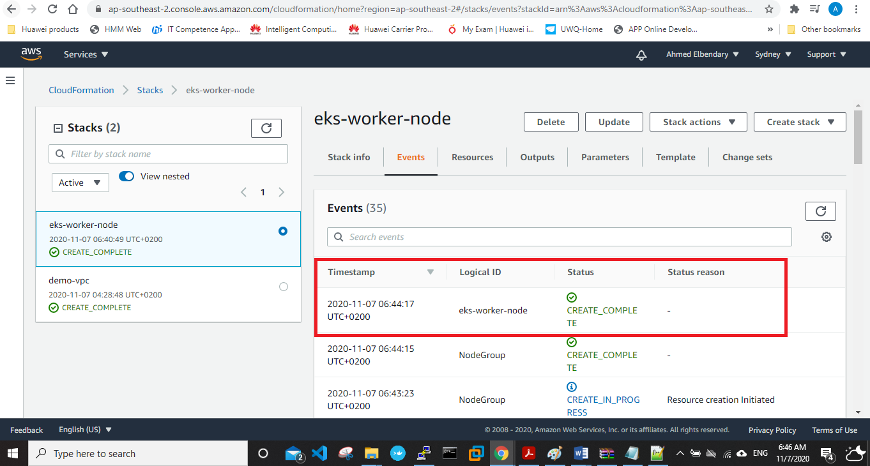

**Copying node instance role arn to add it in configmap file:**

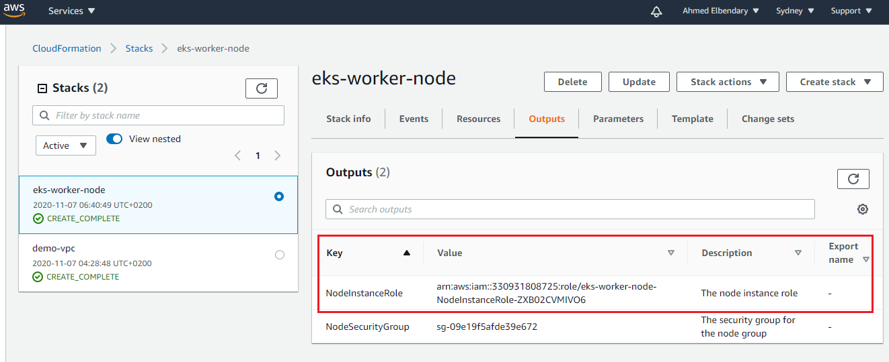

**Downloading configmap file to modify it:**



**Adding the node instance role arn to configmap file:**

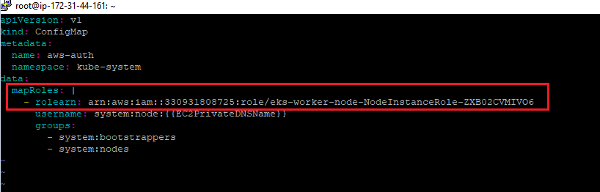

**Applying configmap file:**

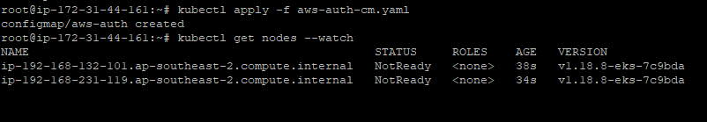

**Creating nginx pod to check on working nodes:**



**Checking on service, nodes and pods:**

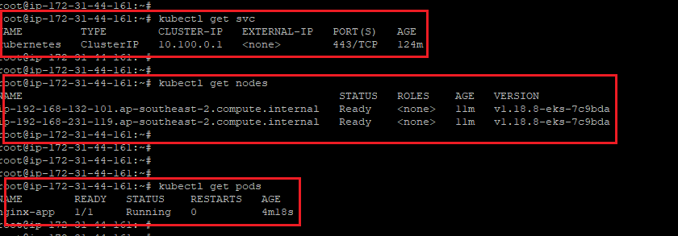

**Checking on added nodes from console:**

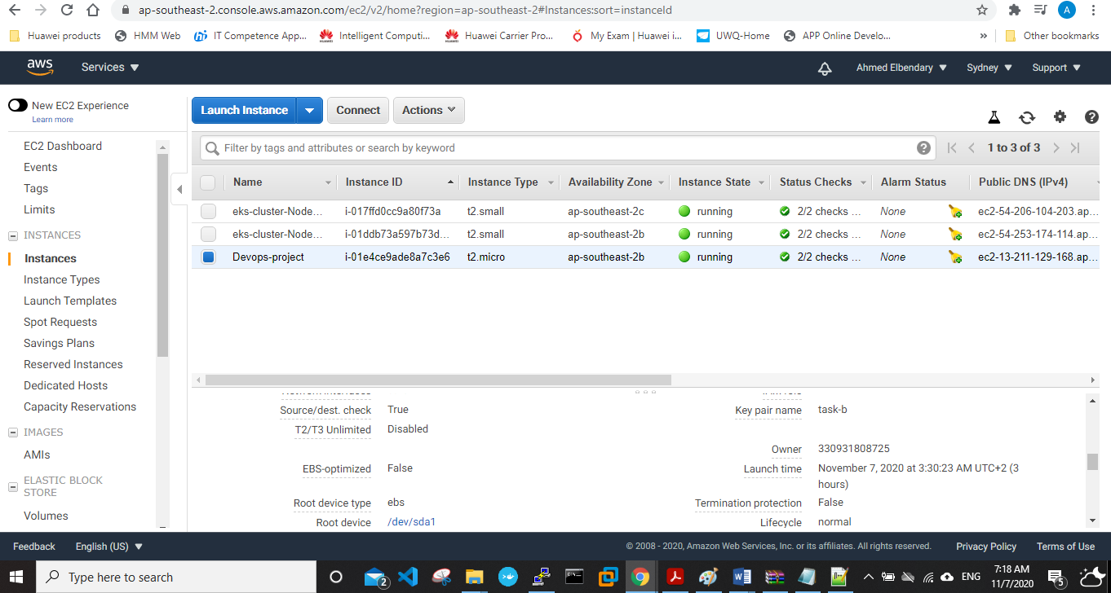

**Requirement 2- partB**

* Created Ubuntu instance on AWS and installed all tools to be used in my instance:

Java/ git/ maven/ Jenkins/ docker/ Ansible

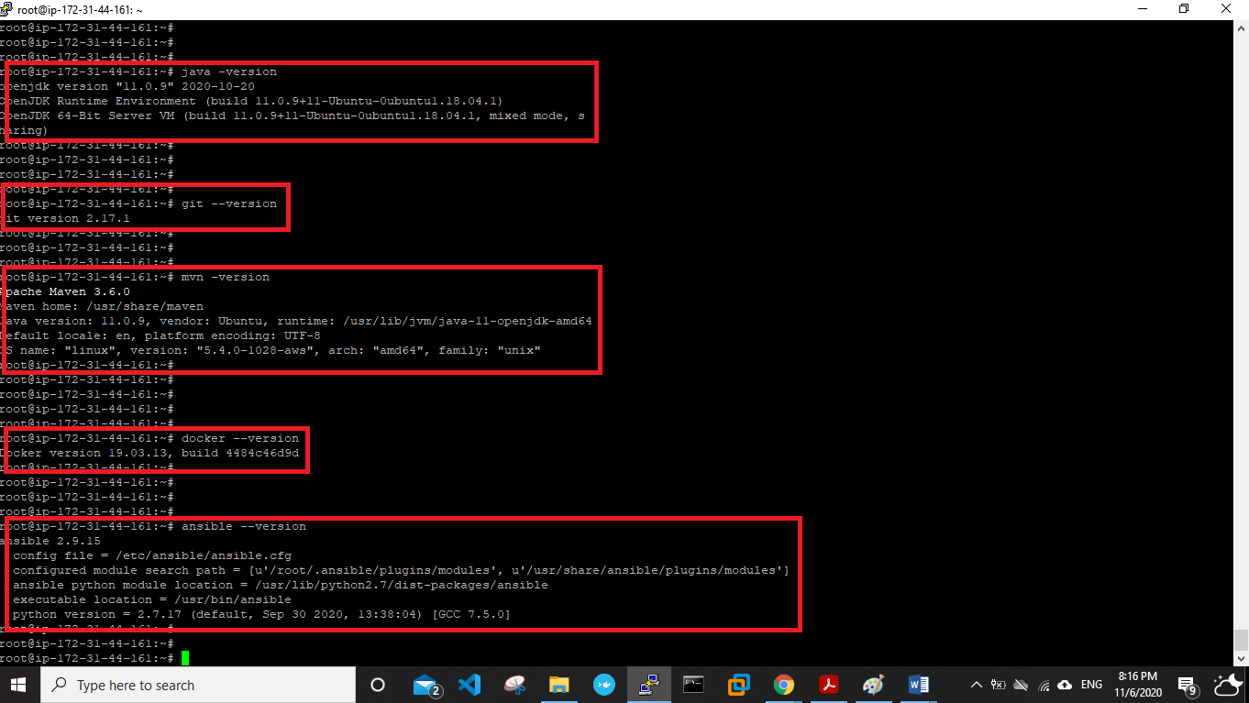

* Docker installed:

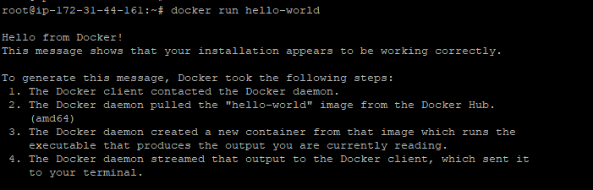

* SonarQube installed:

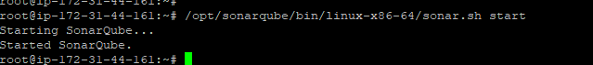

* Jenkins installed:

Refrence link for steps: <https://www.jenkins.io/doc/book/installing/linux/>

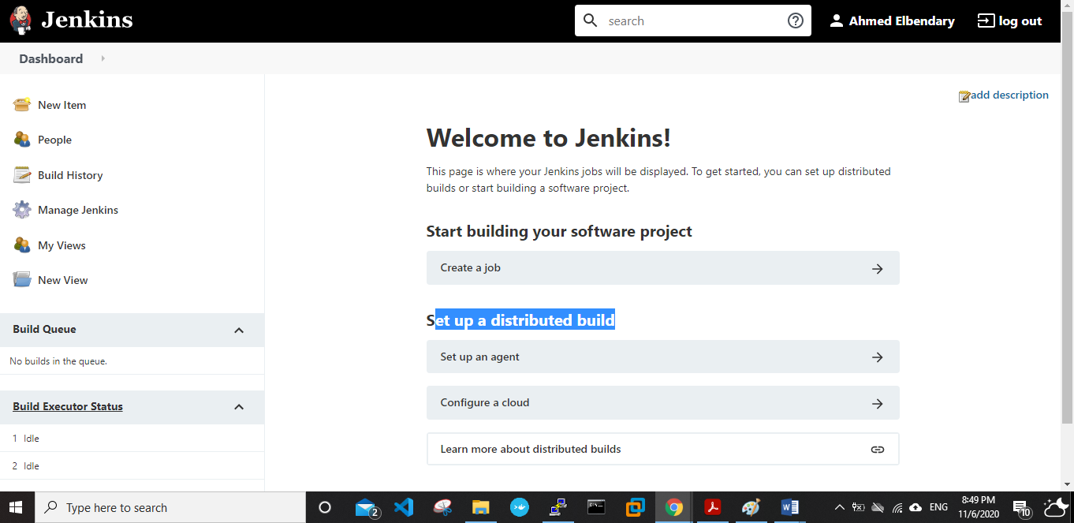

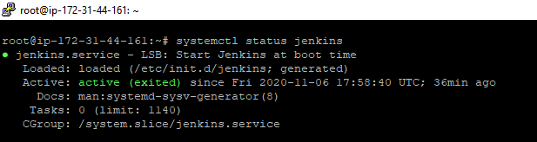

**Requirement 2- partC**

**Pulling an image from docker hub to be used as my app:**

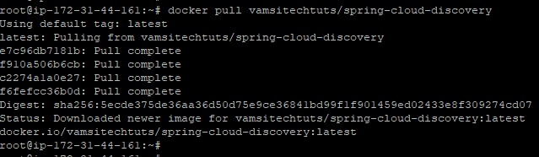

**Successfully added the image**

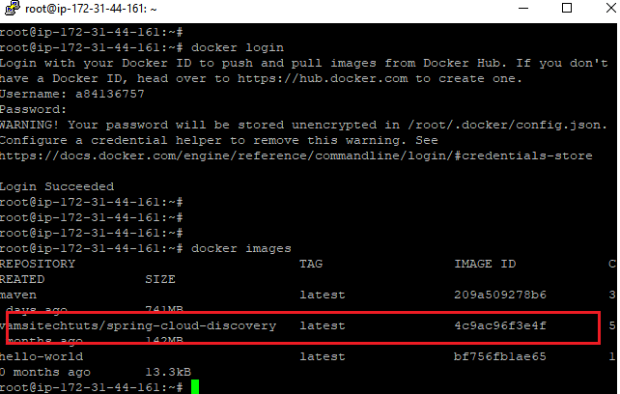

**Pushed the app into my docker hub account to use it :**

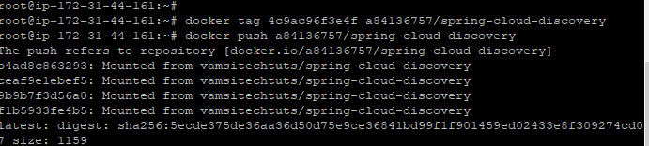

**Verifying the image to be used in my docker repo:**

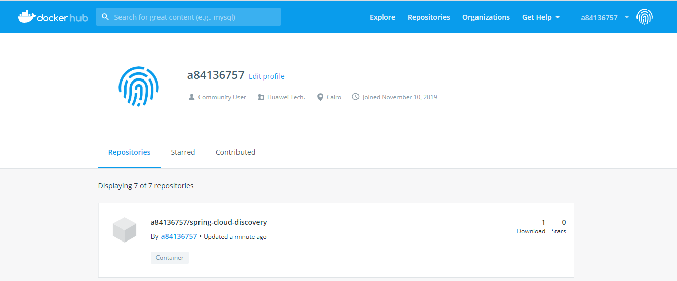

**Installing necessary plugins: Required plugins:** pipeline aws steps - maven - kubernetes- kubernetes continues deploy plugin kubernetes credentials provider.

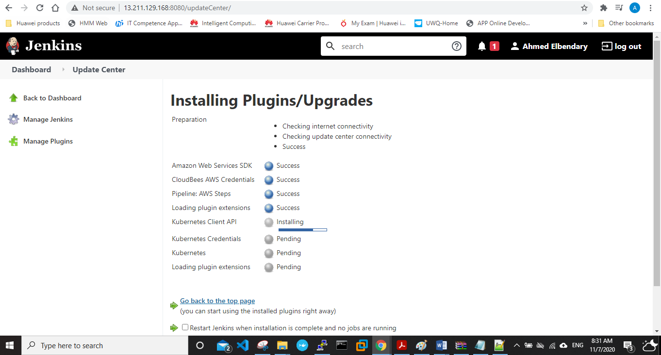

**Configuring credentials used for accessing EKS cluster and docker hub.**

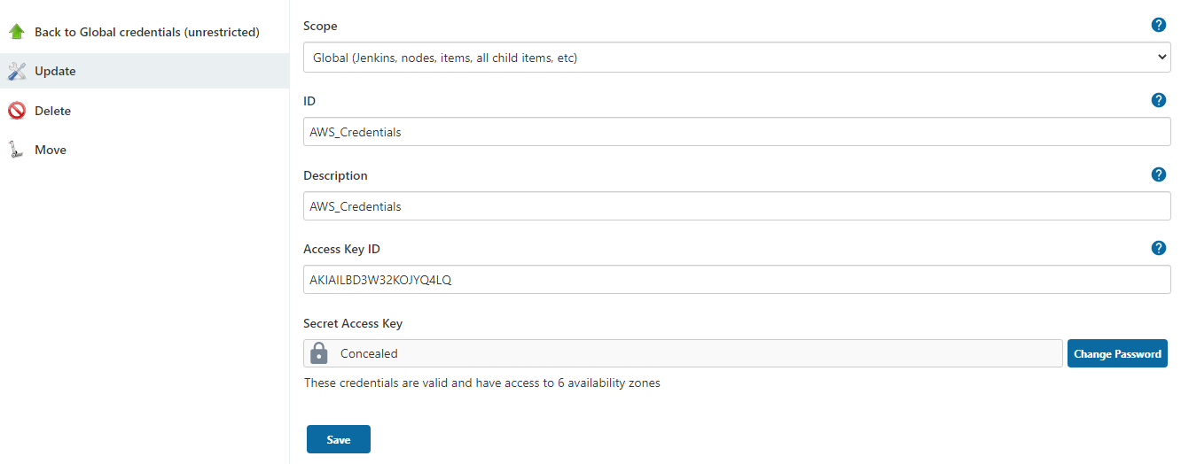

* **Credentials added successfully:**

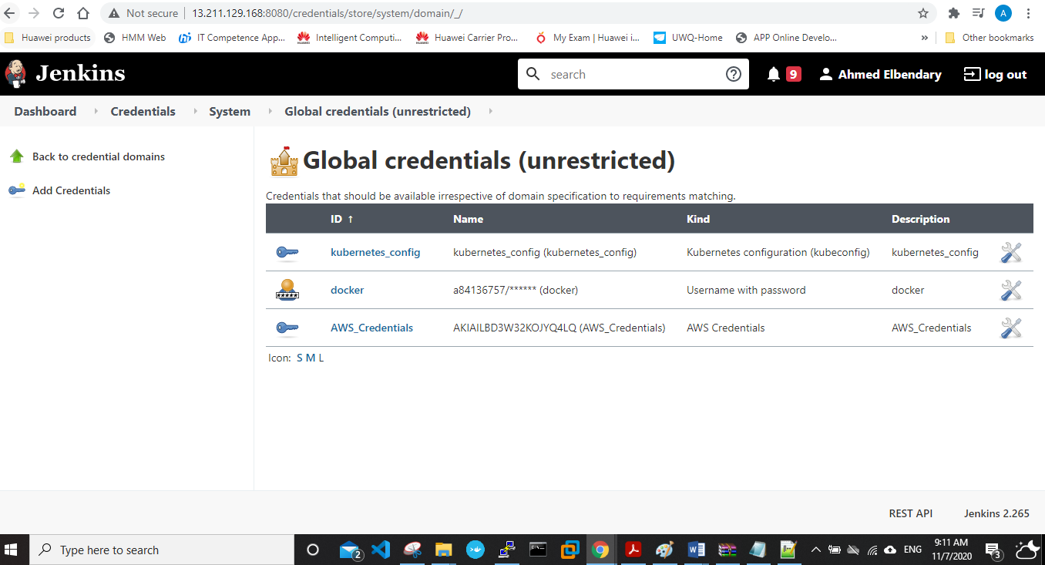

**Create global tool configuration for maven:**

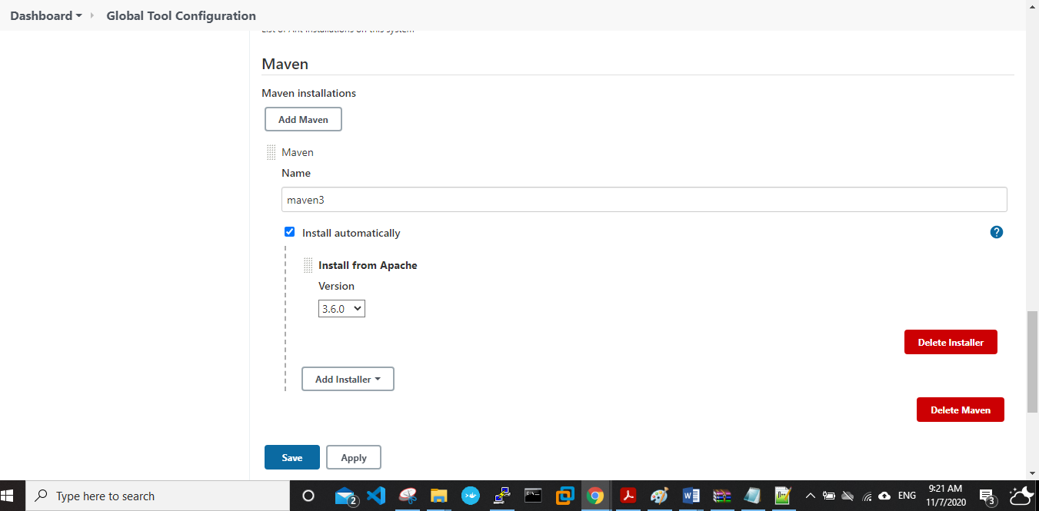

* Created **“**[**Deply_app_to_EKS_using_Ansible**](http://13.211.129.168:8080/job/Deply_app_to_EKS_using_Ansible/)**” pipeline and added code to it.**

Refrence: <https://www.jenkins.io/doc/book/pipeline/jenkinsfile/>

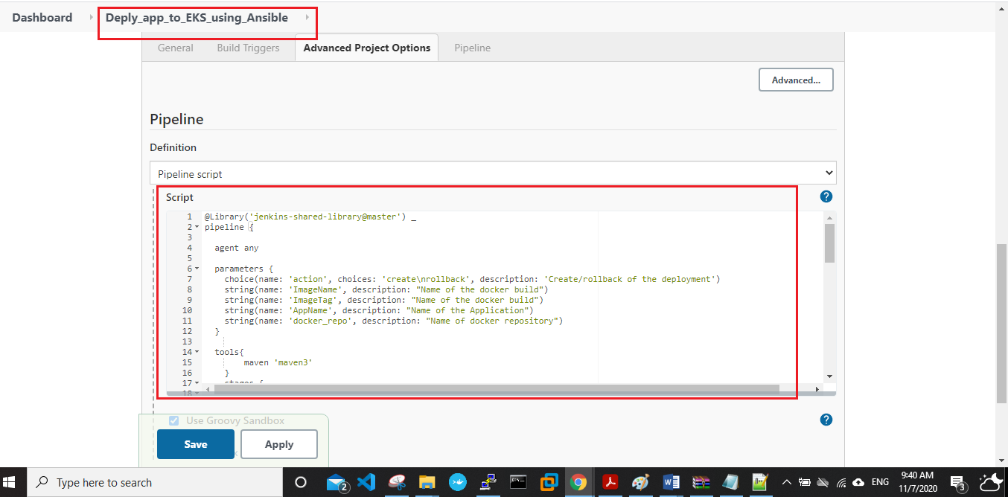

Pipeline failed:

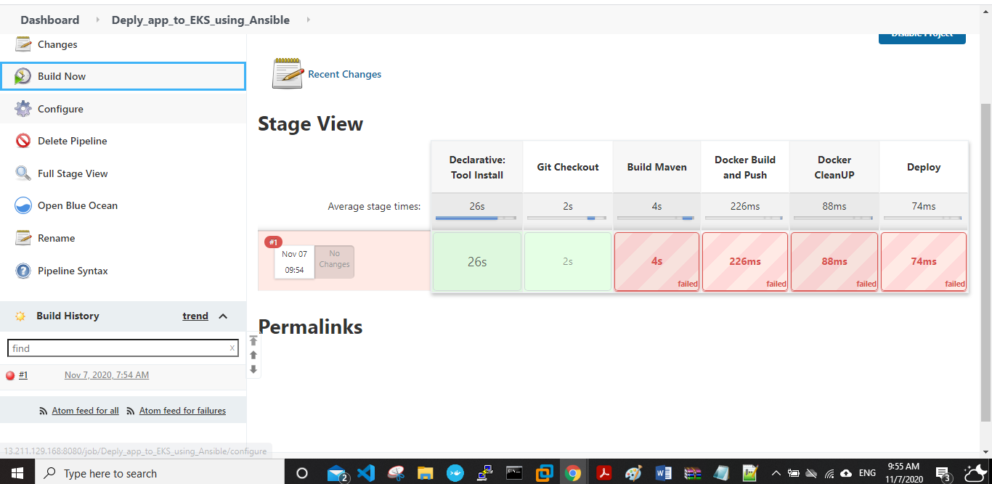

Console output for error:

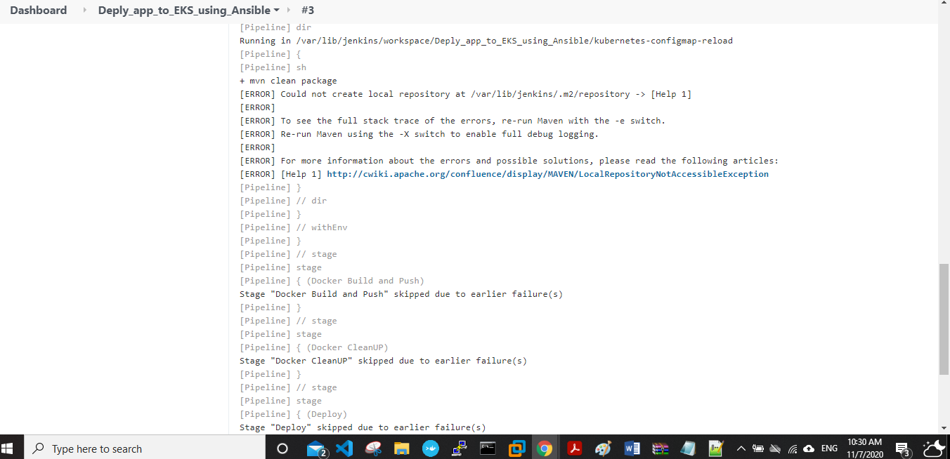

Help 1 link :

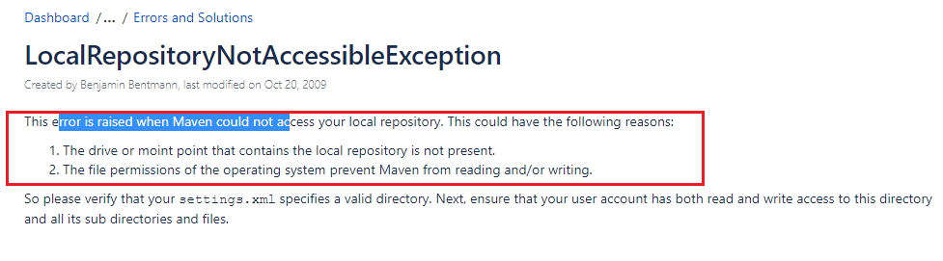

I modified permissions to my Jenkins file as it was read only:



Downloading artifacts from maven repository….

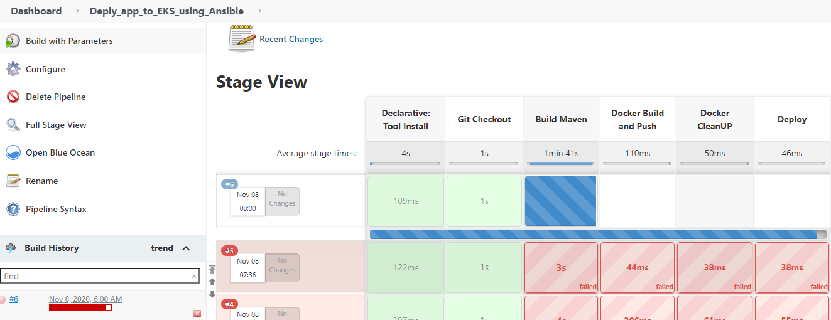

**Update**: after more than 20 min. Jenkins server page stopped loading.

I think it’s because I made all my work on a t2.micro instance ( 1cpu, 1 RAM ) which made it very slow.

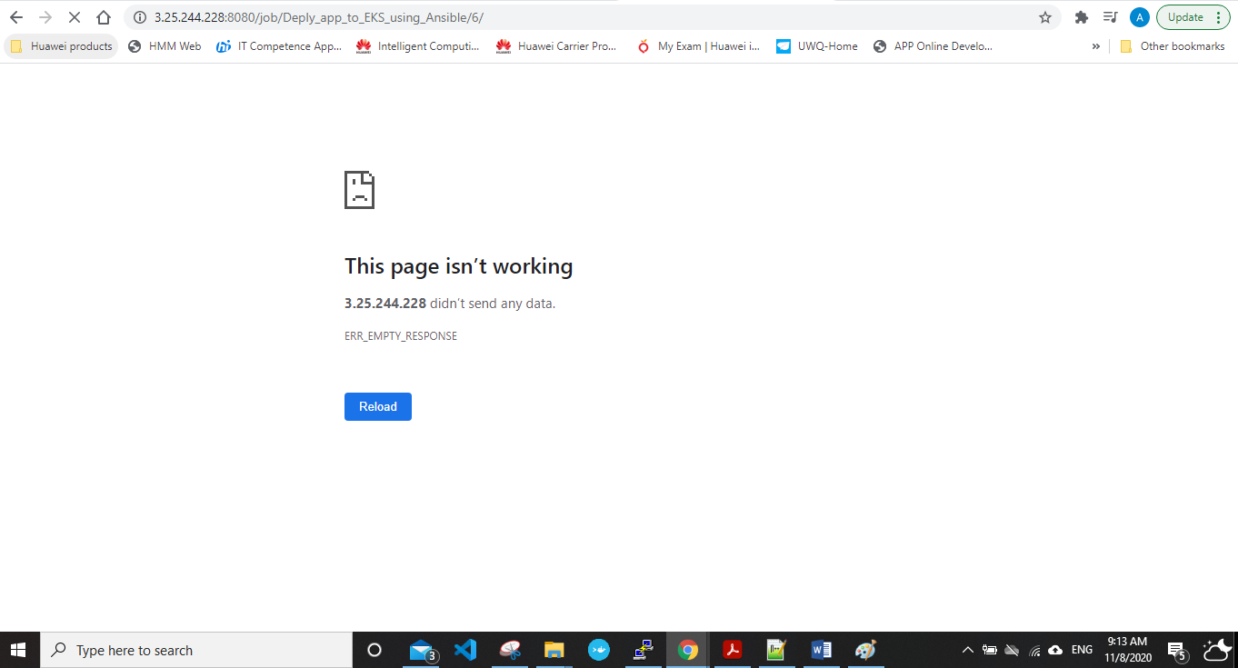

Next step: check if deployments, svc, pods are running or not on kubernetes cluster using below commands( unfortunately after many trials my instance probably is not cabable of doing the build phase with all loads on it, figured this out at late time ). All YML files are mentioned in the github repo.

Kubectl get pods

Kubectl get deployment

Kubectl get svc